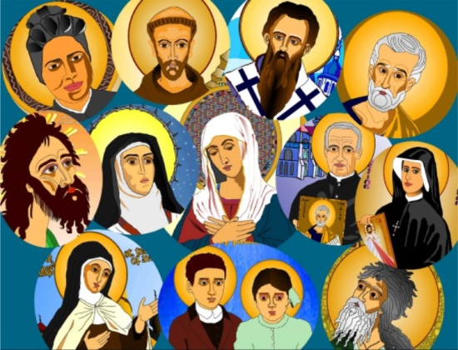
ALL SAINTS
Liturgical Colour: White

Good morning everyone.

Let’s begin our liturgy this morning by making the sign of the cross.
In the name of the Father and of the Son….

And we say together the Morning Offering.
O my God I give to you all that I think and say and do.
All my work and all my play I will give to God today.
Amen

Today we are remembering the Church’s feast called All Saints.
Everyone who is in Heaven is a saint.
Some of them are very well known because they lived special lives
and showed that they loved God very much.

In this reading from St Matthew’s Gospel, Jesus tells us what we have to do to be able to go to Heaven.

The reading comes from the Gospel of St Matthew.
Jesus saw some people and went up on a hill where He sat down.
His disciples also gathered around Him
and He began to teach them.
This is what he said;
“Happy are those who know they are poor.
The Kingdom of heaven belongs to them.
Happy are those who are sad. God will comfort them.
Happy are those who are humble. They will receive what God has promised.
Happy are those whose greatest wish is to do what God wants. God will make them happy.
Happy are those who are kind to others. God will be kind to them.
Happy are the pure in heart. They will see God.
Happy are those who work for peace. God will call them His children.
Happy are those who suffer because they do what God wants. The Kingdom of Heaven belongs to them.
Happy are you when people insult you
and tell all kinds of evil lies against you
because you are my followers.
Be happy and glad
because a great reward is kept for you in Heaven.”
The word of the Lord. Thanks be to God

Let us spend a moment thinking about all these things God is telling us.

The response is ; hear our prayer. Hear our prayer
We ask you Lord to help us to be like the saints ;
to be loving and kind and generous in all that we do
Lord in your mercy ………..hear our prayer
We pray to all the saints in Heaven. That they will watch over us always.
Lord in your mercy……….. hear our prayer
We pray that the way we treat each other , shows that we are trying to live as the saints.
Lord, in your mercy………hear our prayer

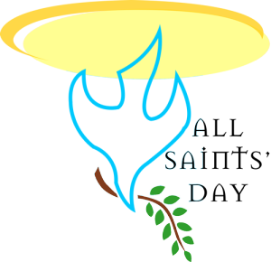

Let us say a prayer to Mary who is Queen of all saints. Hail Mary, full of grace…..

God is the glory and joy of all His saints who we remember today.
May his blessing be with us always. Amen AMEN.

May the prayers of the saints protect us from bad things and may their example of good living help us in
our daily lives. Amen .AMEN.

God is happy that those in the church are happy with Him in Heaven. May we too one day share in that happiness in heaven. Amen. AMEN

And May Almighty God bless us.
In the name of the Father and of the Son and of the Holy Spirit. Amen

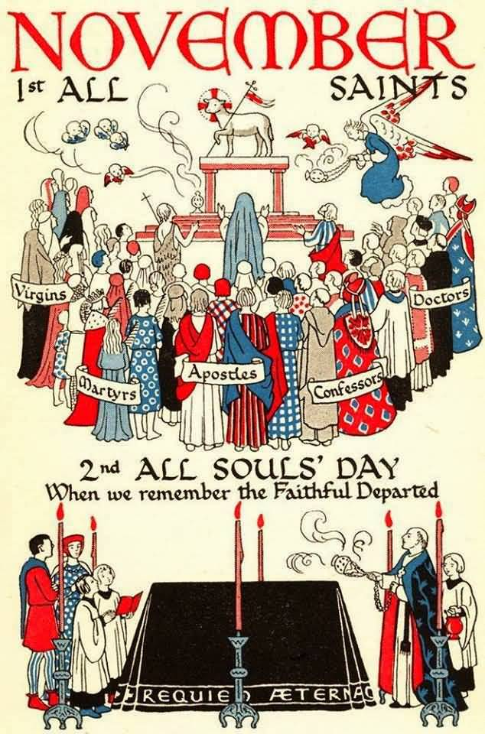
ALL SOULS
Liturgical Colour: Purple

Good morning everyone.

Let’s begin our liturgy this morning by making the sign of the cross.

In the name of the Father and of the Son….

And we say together the Morning Offering.
O my God I give to you all that I think and say and do.
All my work and all my play I will give to God today.
Amen

November is the month of the Holy Souls. That means we remember people who have died, and we pray that they will be happy in heaven.

READING
The reading comes from one of the letters of St Paul.
Dear Friends.
I want to tell you something about people who die,
because I don’t want you to be terribly sad, like other people are, for we are Christians.
We know that Jesus died just as we do.
But then he went to live with His Father in Heaven.
We will do the same.
We will go to live with God our Father for ever.
I am certain of this because Jesus said it was true.
The word of the Lord. THANKS BE TO GOD

This prayer is part of Psalm 15
The response is; Lord we are safe with you;
LORD WE ARE SAFE WITH YOU
We praise the Lord
For he guides us along the right path
LORD WE ARE SAFE WITH YOU
By day and night
He shows us what to do
LORD WE ARE SAFE WITH YOU
We shall not fall down
If he is there beside us
LORD WE ARE SAFE WITH YOU
Lord we are happy
For we are safe with you
LORD WE ARE SAFE WITH YOU

Let us bow our heads and pray.

We pray for all those people in our families who have died.
Lord in your mercy. HEAR OUR PRAYER
We pray for all those people who have died on their own and have had no one to pray for them.
Lord, in your mercy. HEAR OUR PRAYER
We pray for all those men who have given their lives in fighting for our country.
Lord, in your mercy. HEAR OUR PRAYER
Let us say a special prayer for everyone who has died, especially the names on our altar.
Eternal rest give unto them o lord, and let perpetual light shine upon them. May they rest in peace. Amen

Let us pray for a moment in the quiet of our hearts.

In His great love, God has given us the gift of life.
May He bless us in the hope that we will live forever with Him in Heaven. Amen. AMEN
To us who are alive, may he grant forgiveness,
And to those who have died, grant a place of light and peace. Amen. AMEN
As we believe that Jesus rose from the dead, so may we live forever with Him in joy. Amen. AMEN.

And may Almighty God bless us.
In the name of the Father and of the Son and of the Holy Spirit. Amen.

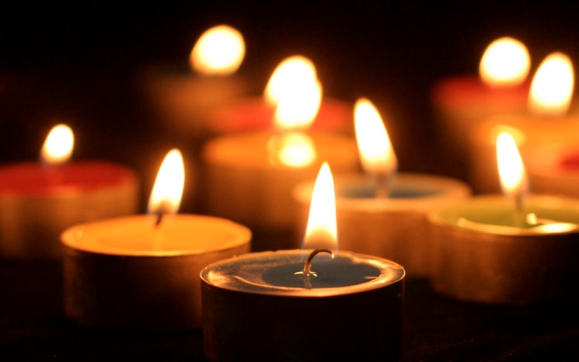
HOLY SOULS

Liturgical Colour: Green

Good morning everyone.

Let’s begin our liturgy this morning by making the sign of the cross. In the name of the Father and of the Son….

And we say together the Morning Offering.

O my God I give to you all that I think and say and do.
All my work and all my play I will give to God today.
Amen

We continue to remember those people who have died. This week let’s think especially about those people who do nit have anyone to say a prayer for them. We are all very lucky that we have lots of people who care for us and look after us. But many people, including children, live without anyone to love them.

READING
The reading comes from the Gospel of St John.
One day Jesus said to His friends
“Don’t get upset ,
trust God the Father and trust me.
There is plenty of room in my Father’s house,
And I am going to get a place ready for each one of you.
Then I will come back and take you with me and you will be able to stay with me for ever.”
The word of the Lord. THANKS BE TO GOD

The response is : Lord you are my protector.
LORD YOU ARE MY PROTECTOR
You know me Lord so very well.
You know each thing I do.
LORD YOU ARE MY PROTECTOR
You know what I am going to say before I speak.
You are always close to me.
LORD YOU ARE MY PROTECTOR
If I climbed the highest hill,
You would be there with me.
LORD YOU ARE MY PROTECTOR
If I swam beneath the waves,
You would be there with me.
LORD YOU ARE MY PROTECTOR
Even in the dark of night
You would be next to me.
LORD YOU ARE MY PROTECTOR

God of might and power.
Bless those people who are lonely and have no friends. Help us to make friends and let our friendship help them come to know your love.
Amen

Let us pray
We pray for the lonely and unhappy.
That God will watch over them with His loving care.
Lord in your mercy. HEAR OUR PRAYER
We pray for those who are sad because someone they know has died. That they will be comforted in knowing that their friend or relative is in Heaven.
Lord, in your mercy . HEAR OUR PRAYER

We pray for those who have died and have no one else to pray for them.
ETERNAL REST GIVE UNTO THEM O LORD, AND LET PERPETUAL LIGHT SHINE UPON THEM. MAY THEY REST IN PEACE. AMEN

And for all these people we say the prayer that Jesus taught us to say. OUR FATHER WHO ART IN HEAVEN…….

May our loving God who consoles everyone who is upset, watch over us this week and guide us in our studies. And may he bless us. In the name of the Father and of the Son and of the Holy Spirit. Amen.

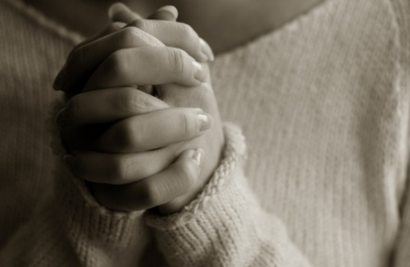

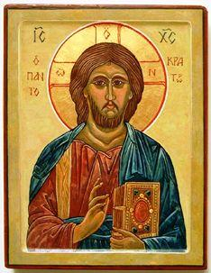
CHRIST THE KING
Liturgical colour; White or Gold

Good morning everyone.

Let’s begin our liturgy this morning by making the sign of the cross.
In the name of the Father and of the Son….

And we say together the Morning Offering.
O my God I give to you……

At the end of the Liturgical Year, just before Advent starts, the Church celebrates the feast of Christ the King.
Jesus was not only the King of the Jews, as people called Him. He was, and is, the King of all Creation…of Heaven and Earth.

The reading comes from one of the letters of St Paul.
Dear friends,
Jesus died. He was killed.
But God the Father has raised Him to life again.
He has made Him the King of the world,
And put Him in charge of everything.
In fact God the Father
Has made Him greater than everybody else.
The word of the Lord. THANKS BE TO GOD

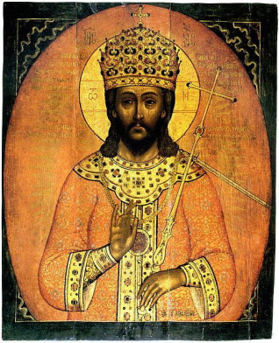

This reading comes from the Gospel of St Mark.
One day Jesus said;
“Lots of things will go wrong
and people will hurt you,
but don’t be afraid.
In the end , you will see me again.
I will come back and you will see that I am King of the world. Then I will send out my messengers over all the earth, and I will bring all my friends together,
And they will be happy with me for ever.”
The word of the Lord
THANKS BE TO GOD

Our prayer is part of Psalm 46.
The response is : God is King of all the earth.
God is king of all the earth.
Clap your hands and shout for joy.
God is king of all the earth.
Play the trumpet loud and clear.
God is king of all the earth.
Sing and praise Him ,everyone.
God is king of all the earth.
Praise Him now with all your skill.
God is king of all the earth.

Let us say our own prayers quietly in our hearts .

Because we are still in November, Let us pray for all the Holy Souls, especially those people who we know.
Eternal rest give unto them O Lord, and let perpetual light shine upon them. May they rest in peace. Amen.

Lord, you give us Christ the King of all creation.
Help us to live by His gospel,
Building His kingdom here on earth,
Where He lives and reigns for ever and ever.
Amen

May Christ the King bless us.
In the name of the Father and of the Son and of the Holy Spirit. Amen.

